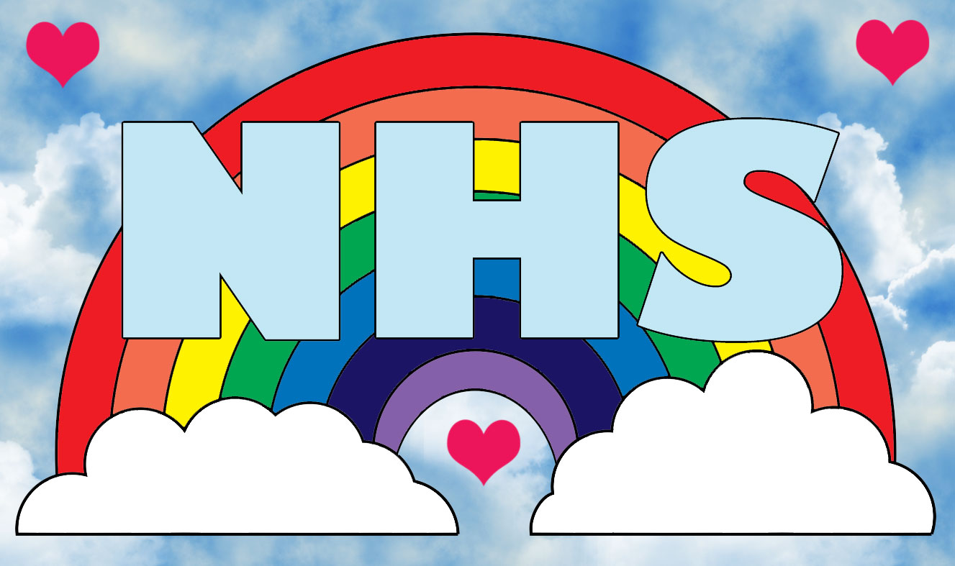

Certificate of Achievement
Thank you for staying at home, and supporting key workers.
Well done for keeping your Scout Promise and for doing your best.
Congratulations to: .......................................................................
From: …………………………………………………………………….
Date: …………………………..
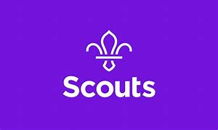
#WashHands#StayHomeSaveLives

